On A Rainy Day:

Description: This is a rather weird, artsy game about controlling a tree made out of hands. You must grab umbrellas with the hands and protect paper boats from the rain as they float across. For every five paper boats that make it you get a new hand and umbrella from the sky. You must pick these up to help your tree grow. You can release an umbrella (right click) and it falls back into the water. Finally, there are red bonus boats. If you help them across, they give you a ton of new hands and umbrellas. The final objective is to make your tree reach the top of the screen.

What went wrong:
- As it may be evident from the rather lengthy description, the game is hard to understand. Why do the paper boats cross over and give you new hands and umbrellas?
- Many people did not realize what the final objective was (to grow to the top)
- The instruction screen has more than three lines of instruction on it
- Since the hands and umbrellas overlap in the water, its frustrating when the user tries to pick up a hand but gets and umbrella instead
- Finally, the interest curve takes a dive when the tree is wide enough to help boats across on its own and the user doesn’t realize that the goal is to grow higher.
- Not enough depth to the game even though there are many rules

What went right:
  - There are many “oh cool!” moments in the game. Eg. Catching a hand or umbrella mid-air or the applauding hands at the end (a brilliant idea by Kyle Gray)
  - Bonus boats
  - The sound complements the game well. Special attention was paid to panning the volumes of “rain on umbrella” and “rain on water” sounds depending on number of umbrellas present
  - The art came together well and the inverse kinematics control on the tree feels pretty fun

What I learnt

  - Art – wise, I experimented with getting real world images and massaging them till they look appropriate in the game. This worked out really well.
  - The approach taken was to do a lot of concept art before actually writing any code. This is a good quick approach (although, overdone on this project). See the conceptualization section below for all the concept art.
  - I don’t think this game gets enough depth for the number of variables it poses. I hope I could have done better with that.

Physics:
See this great article on Verlet integration and stick constraints:
http://www.gamasutra.com/resource_guide/20030121/jacobson_01.shtml

Proposed Modifications
- Tighten up the theme so that there is some link between the boats and things falling from the sky
- Add something to the top of the screen that begs the user to grow the tree higher hence making it obvious what the goal is
- Make it an “unlimited” game with levels, obstacles various difficulties etc.

Conceptualization:
The theme chosen was trees or vegetation. Trees are a great area to explore for games because of the following (and many other) reasons:
- Everyone can identify them
- They are wonderfully self-repeating
- They have the property of growth
- They are amenable with computer based data structures

Having chosen the theme I decided not to write code until I fleshed out my concept entirely. As it turned out this was not the right thing to do because I found that to further the concept I needed to prototype something playable. At the same time the concept needs a certain level of detail so the prototype can be made in the right direction.

This game took 14 days to make. It’s safe to say that for 7 of those I didn’t write a single line of code that actually made it into the game. In fact there is a whole different prototype that I spent the first 7 days on. It looks like this:
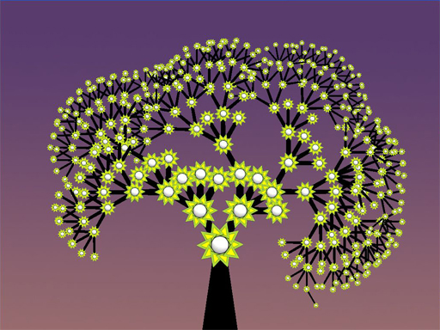

or like this:
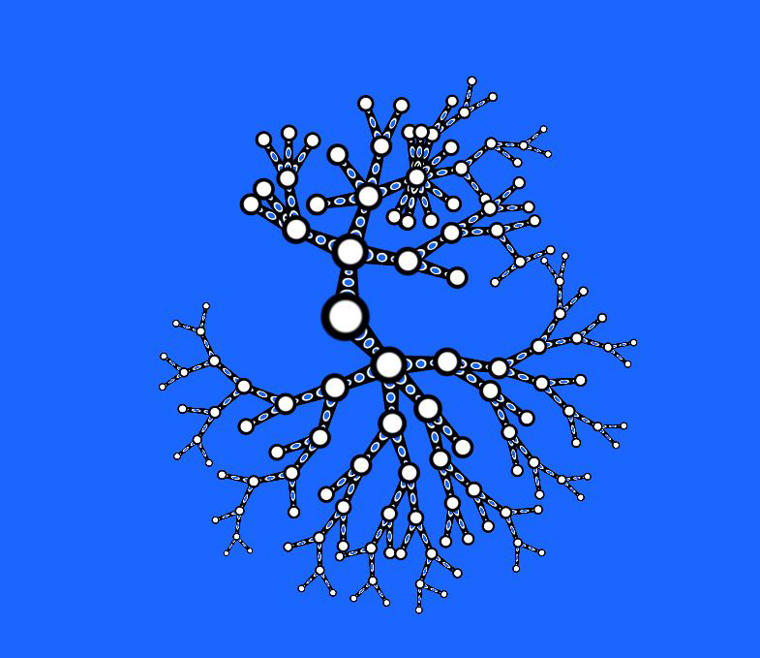
It has an interesting interaction where you rotate a node around its parent and the number of rotations is how many children that node springs when you let go:
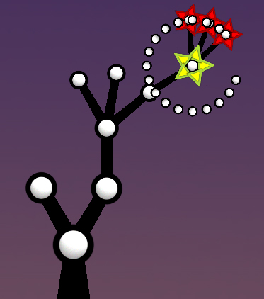
I am yet to make this toy into a game.
What I discovered while making Cytoplasm, my previous game, was that it is really useful to prototype the art first. This inspires you to build the game and gives a clearer idea of where to take it. So throughout my conceptualization stage I drew a whole bunch of ideas on paper and mocked them up quickly in Photoshop. Here’s a quick chronological list:
1) Buildings on a tree
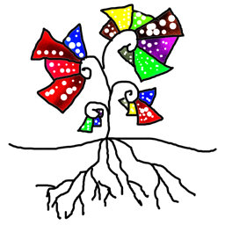
2) Trees on a rotating planet need sunlight to grow. Manipulate roots at night to get resources. Creatures on surface chop trees and go to sleep at night- tree can eat them then.
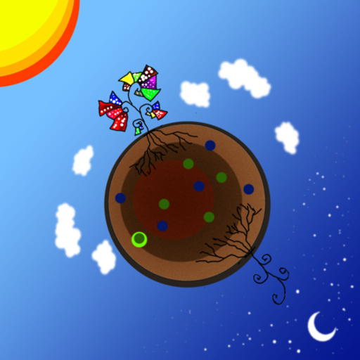

3) Tree of pipes guiding something – collecting or spraying
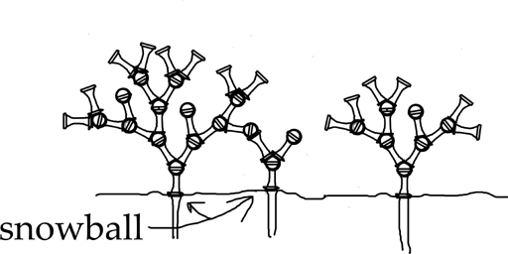
Atlanta Airport
The next few ideas were all conceived on Atlanta airport where I was stuck for 15 hours thanks to a storm and Delta Airlines.
4) The Juggling Tree:
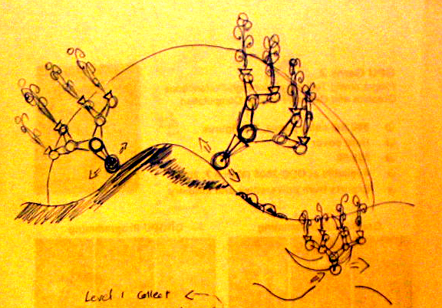
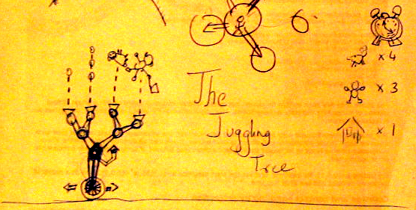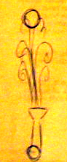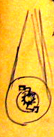
A tree on a unicycle juggling and moving around

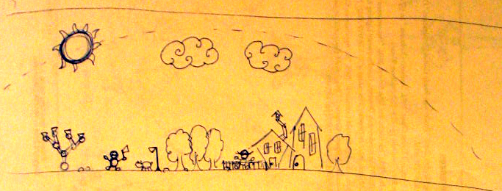
Going across a town picking up objects to juggle

5) On a Rainy Day
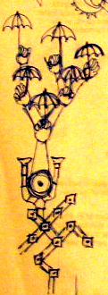
This was the original concept art behind the game I ended up completing

6) Plunger Guy
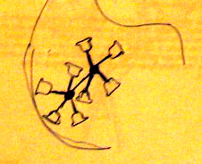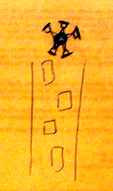
Not really a tree but a similar IK system with suction cups at the ends

7) Crazy hair girl
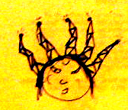
8) Cute Expressive Face Tree
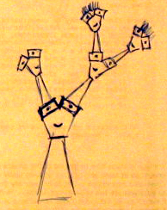

9) Just some ideas for backdrops

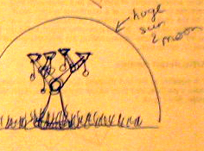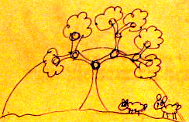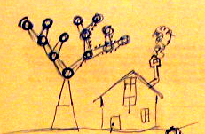
Das Rad… Time lapse?
10)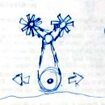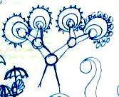 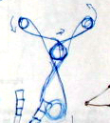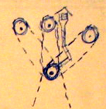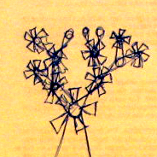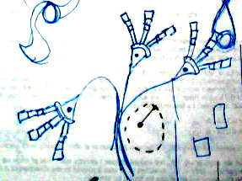 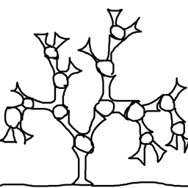
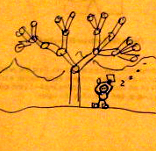
Just a bunch of other tree sketches
11) Rainy day with the rain actually falling off the umbrella
